Octavio Morales
CS 561- Final Exam
17 December 2025

- Based on the information, the only R-pairs are (X1, Y2) and (X2, Y3), as it is specifically stated that “no other pairs of instances of X and Y are related by R”. Therefore we can conclude such:
I. It is consistent because the diagram shows that each X relates to at most 1 Y while each Y relates to at most 1 X. Since the assumptions only have one pair in regards to each instance of X and Y, our data has max 1 on both sides.
II. It is consistent because the diagram shows that each X relates to at most 1 Y while each Y can be related by any number of X. Since the assumptions only have one pair in regards to each instance of X and Y (either at most 1), both relations have their requirements met.
III. It is consistent because the diagram shows that each X can be related by any number of Y while each Y relates to at most 1 X. Since the assumptions only have one pair in regards to each instance of X and Y (either at most 1), both relations have their requirements met.
IV. It is consistent because the diagram shows that each X can be related by any number of Y while each Y can be related by any number of X. Since the assumptions only have one pair in regards to each instance of X and Y (either at most 1), both relations have their requirements met.

- I. Key of Entity Set A= a1, b2, c1
This is because A is a weak entity (based on the double box) with partial key a1 (based on the dotted underline), so its full key is its partial key with the owner keys reached by following the double-diamond identifying relationships back through B (b2) to strong entity C (c1).
II. Key of Entity Set B= b2, c1
This is because B is weak with partial key b2, and its identifying relationship ties it to strong entity C with key c1.
III. Key of Entity Set C= c1
This is because C is a strong entity and c1 is a solid underlined as its key.

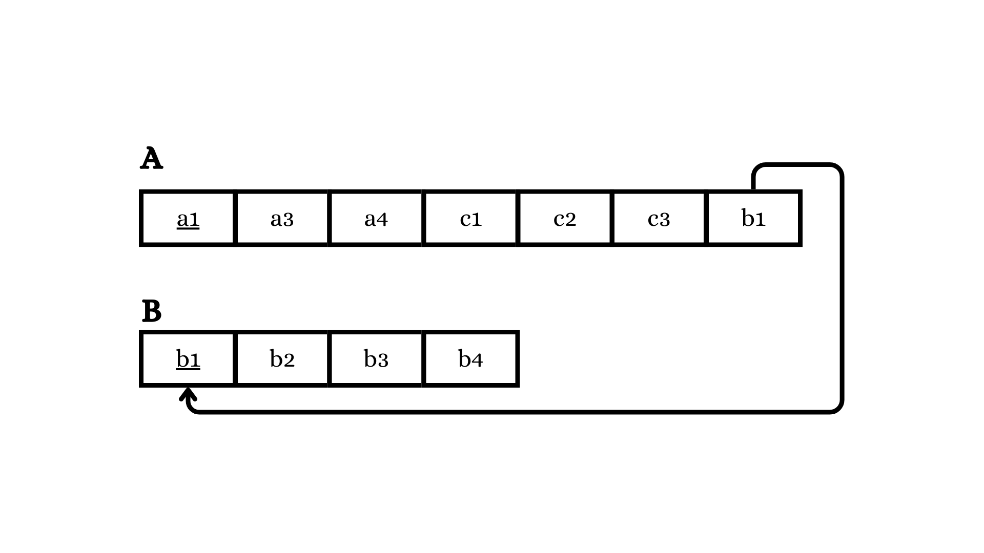
This is a minimal storage relational design because for this N to one relationship, I copied the key of 1 side (b1) into the N side table (instead of creating a separate table for the relationship). Since B is the 1-side, we copy B’s key b1 into A, which is why b1 in A is connected to B with the arrow for the foreign key reference.

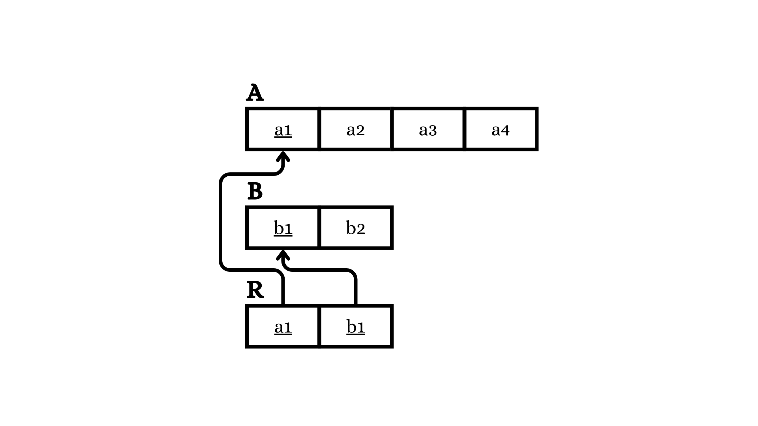
This is a minimal storage relational design because the relationship is many to many as shown in the slide, so I had a separate table for R. If not, I’d have to store multiple b1s per a1 or multiple a1s per b1 inside a single row, which isn’t feasible in this setting. The double line constraints would affect allowed data, but it would not affect the minimal table structure.

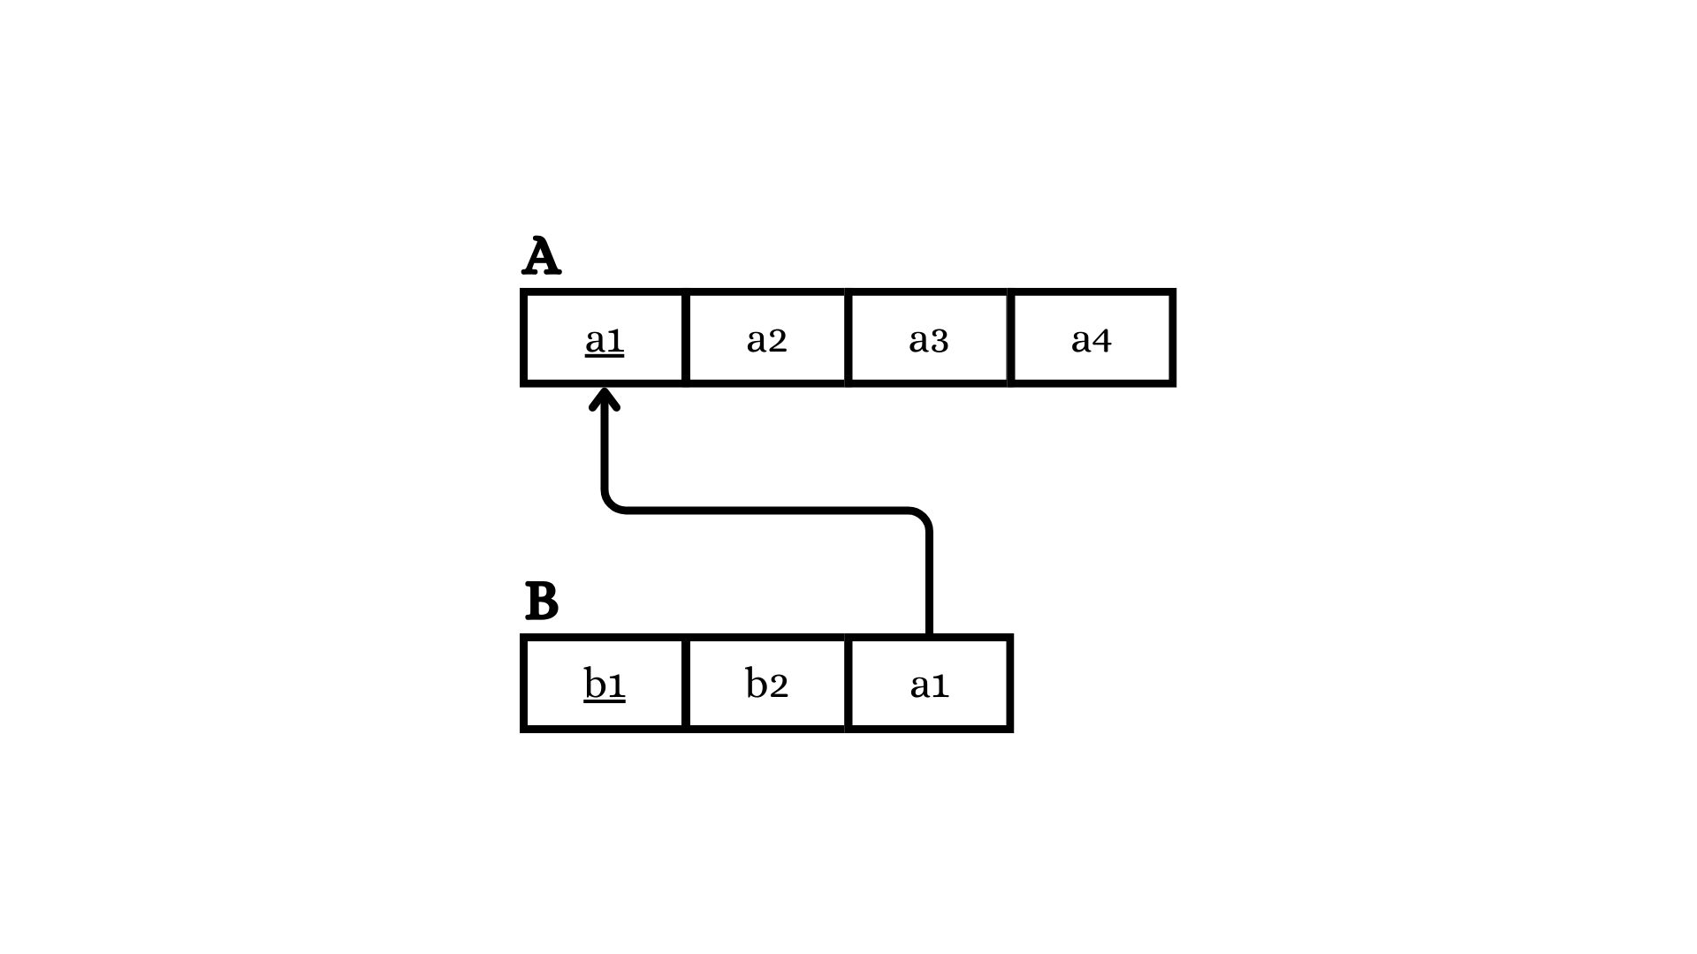
This is a minimal storage relational design because for this one to one relationship, I stored one side’s key (b1) as a foreign key in the other N side table (A) rather than making a separate R table.

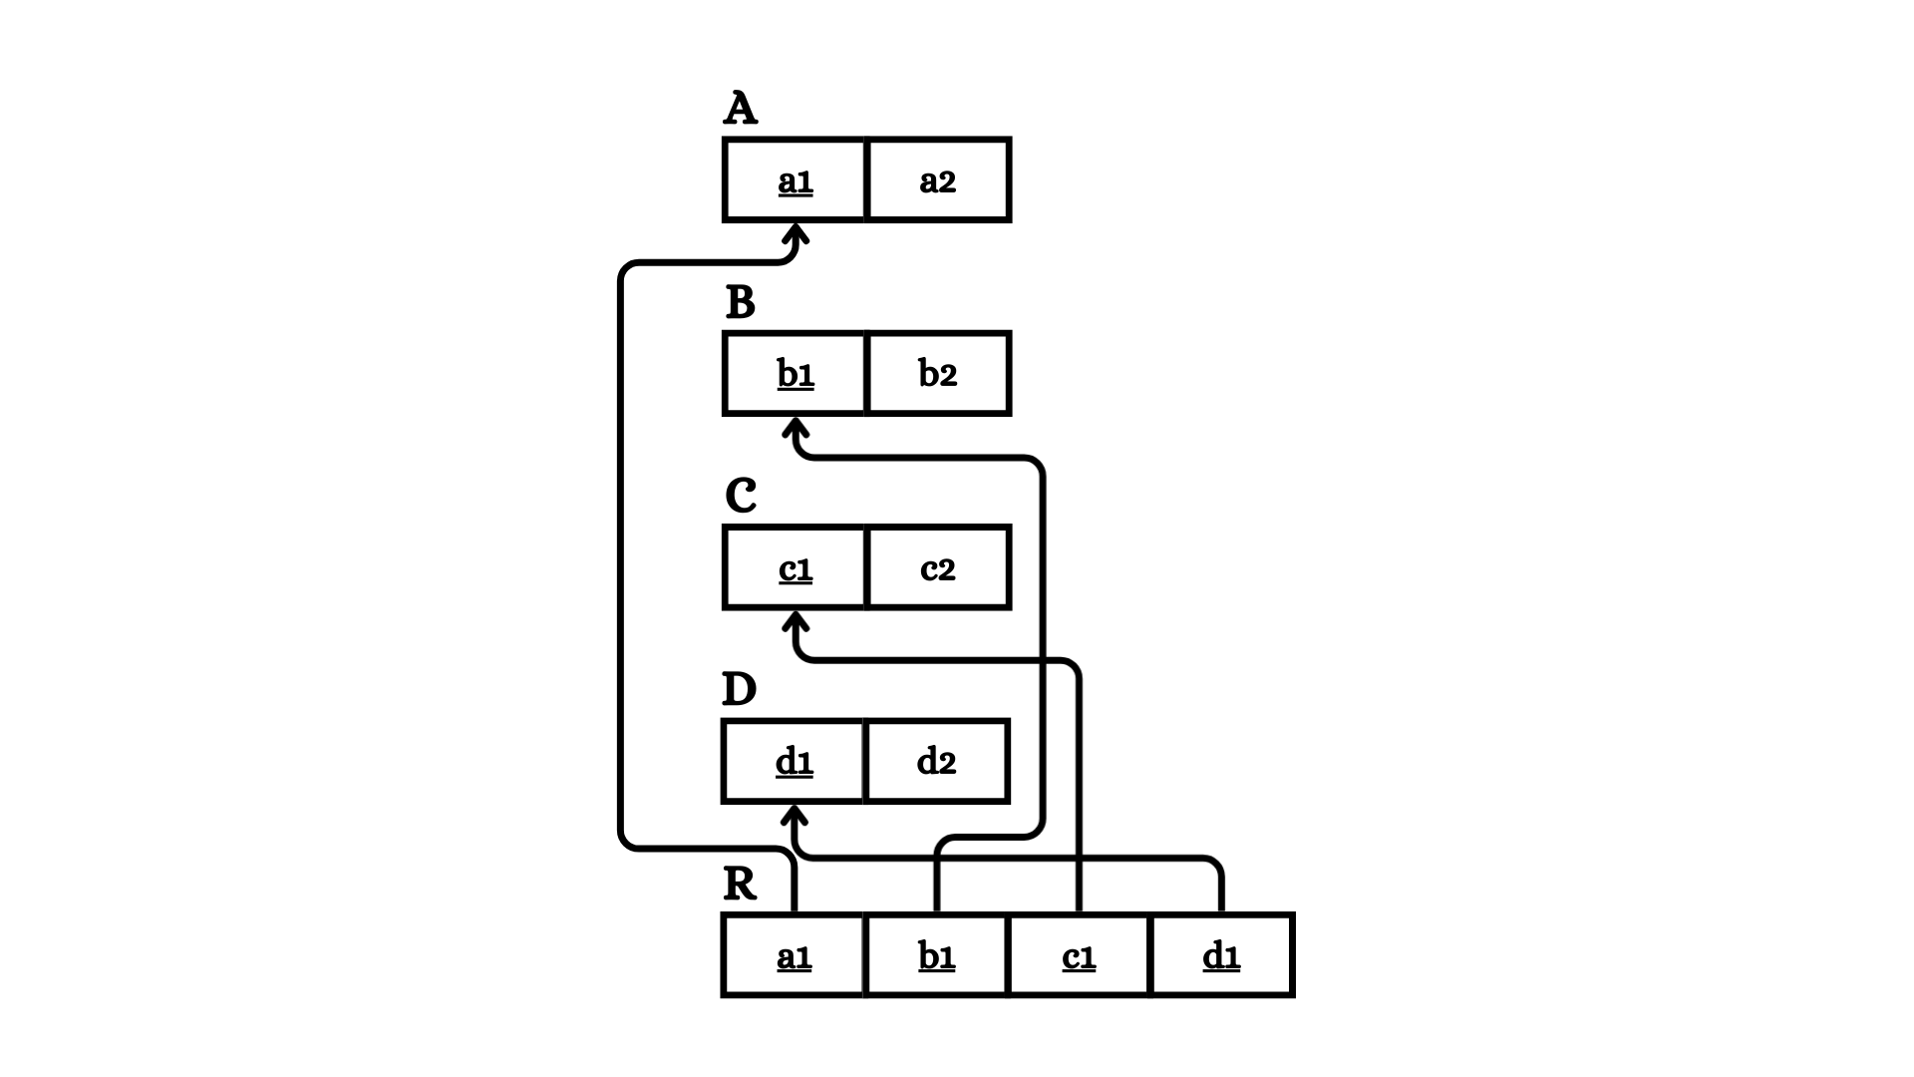
This is a minimal storage relational design because for this four way relationship between A, B, C, and D, I assumed there were no constraints in the relations as there were none listed, and like question 4, I made a separate R table to store such.

